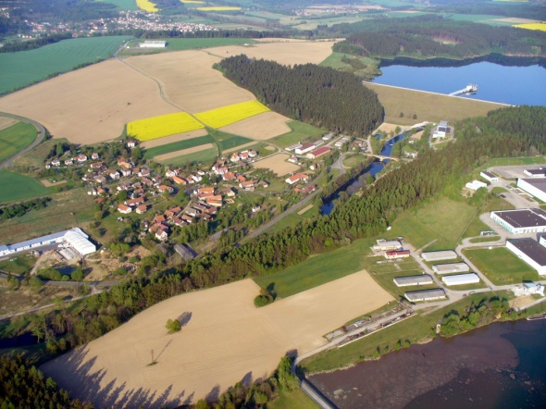
I‘m writing about my village and surroundings where I grew up. I was born in Kutna Hora. The city is the capital city of the district Kutna Hora in the middle of Bohemia which is thirty kilometers from my village.
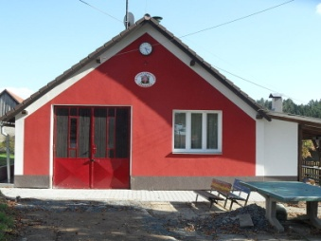
Well, let me intoduce my lovely village. It is called Nesmerice and is located not far from the town of Zruc nad Sazavou. Around the village are forests, fields, meadows and also a big dam. The dam is a water reservoir with drinking water for the capital city of the Czech Republic, Prague. From the dam flows the river Zelivka, which flows through the village. Residents of Nemerice commute to the nearby cities or to the capital city.
In the middle of the village we have a fire club which is used for meeting people, fun, drinking and brainstorming about a new activities in the village. At the end of the village we have also a house of culture where we used to organize balls, weddings and a various celebrations.

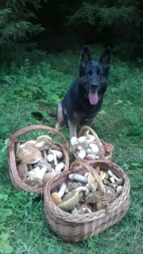
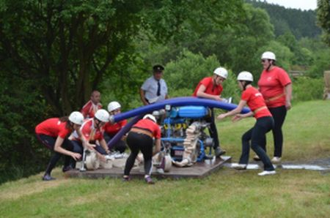
T he village has around one hundred people. Yes, it‘s very small, but I had had a lot of fun there. For example I did a fire sport for 10 years. We had a girlsteam of about seven people. I’ve been attracted to the sport. My task was, at the best time, spray water onto a target. Our team was almost always succesful and we won some cups. Annually we organize celebration of a major cup of Zruc nad Sazavou, which is fighting competition of fire sports with sports teams from a nearby neighborhood.
In summertime we used to go looking for mushrooms, swimming in the villages swiming pool, bicycling, canoeing and fishing on our river, as well as other activities.

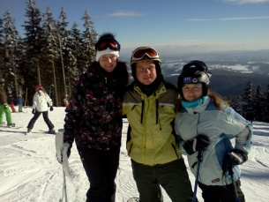
In winter time we used to do cross-country skiing, skiiing on the mountains of the Czech Republic, ice skating on the frozen dam, river and swimming pool, swiming in a waterworld near Prague.
To do other sports activities we have built a completly new multipurose sports playground in which we mostly play tenis, basketball, football and voleyball.
Definitely this area it‘s worth it a visit.

Marketa Prenosilova

