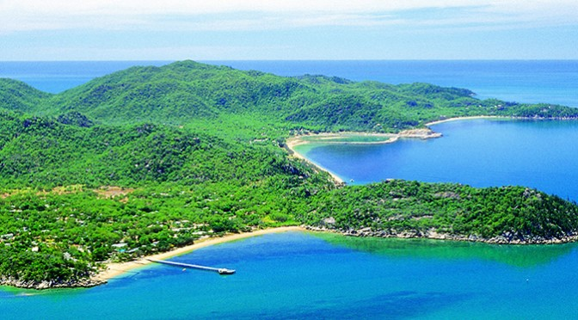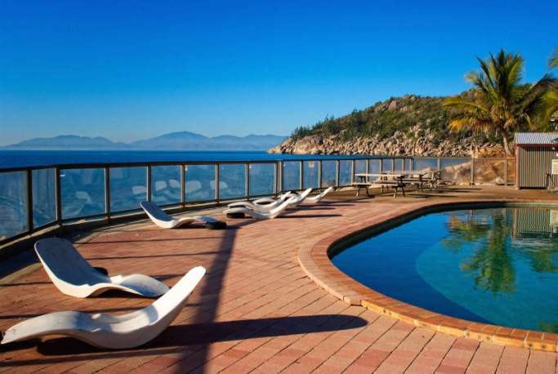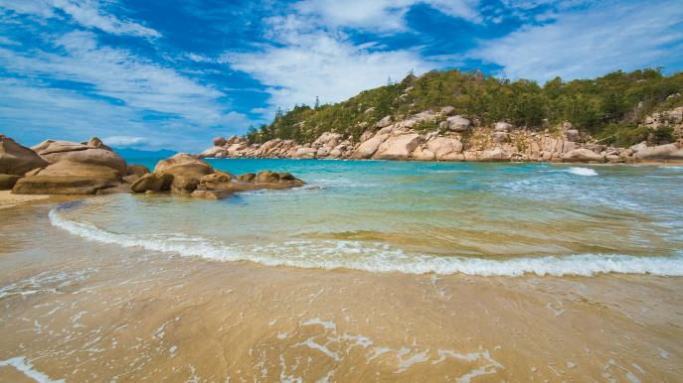

$135 pp

***Extra: Return bus tickets with Premiers Bus***

**$105 Cairns -Townsville 07:25-13:00 on 15/04  
 Townsville - Cairns 13:50-19:30 on 17/04**

Inclusion:

* 3 nights in a 6-8 BED DORM
* Ferry Return Tickets
* 1 dinner
* 1 breakfast
* 1 welcome drink
* 1 day snorkeling equipment hire

**For more information talk to our tour desk staff at Lake 67**

Magnetic Island Escape

4 days 3 nights Easter Trip