The Great Barrier Reef
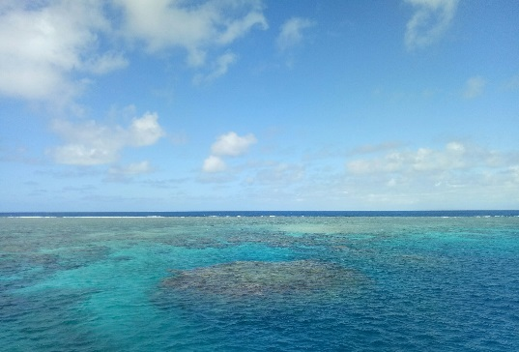
After one year in Cairns, I have not had the opportunity to experience one of the main attractions of Cairns, Australia and even the world, which is The Great Barrier Reef! But, thanks to working with the amazing team at Lake 67, the travel agent of Cairns College of English, finally I visited this beautiful place – and I fell in love with the diversity of marine species and of corals – and its captivating mix of colors.
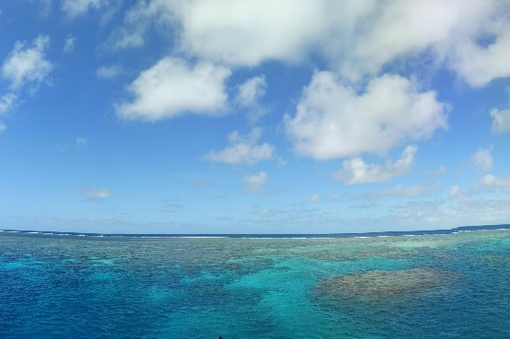
The Great Barrier Reef is the biggest coral system in the world – it is such a large living structure that you can see it from outer space, which is amazing!
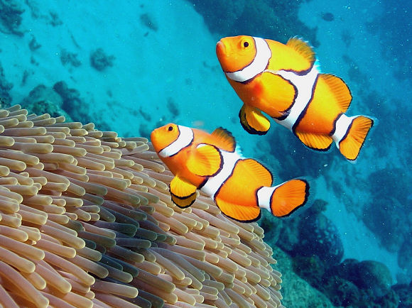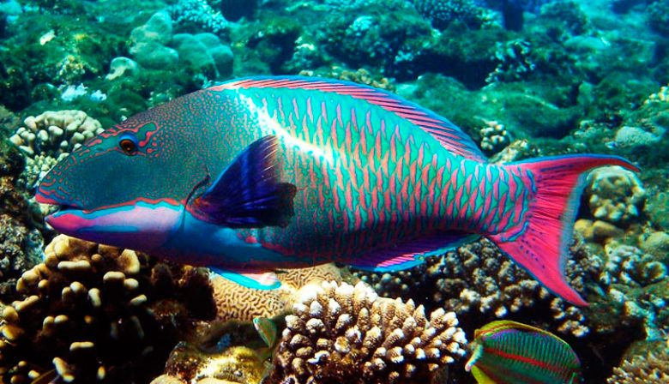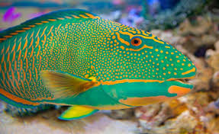
Anyway, I went snorkeling and it was a beautiful experience. I could see a variety of fishes, including the famous clownfish – better known as Nemo – and also parrot fish in many different colors, which for me was one of my favorites with its flashy colors, but the most beautiful species that I encountered was the blue sea-star, which was gigantic, stunning, and vibrantly blue.
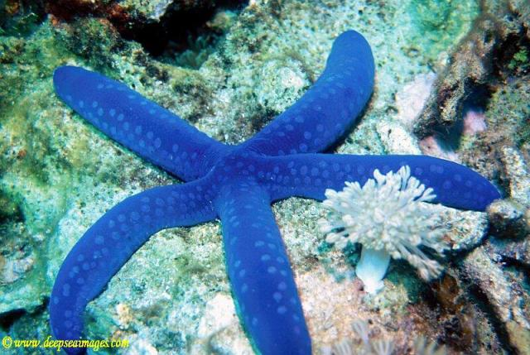
Incidentally, the months between June and November are the perfect time to see whales, and although I did not get close, I could still see them from afar.

As for the Company that I went with, I would like to say that the staff were highly qualified, very kind, with great concern for customer service. The boat was comfortable and the food was delicious!
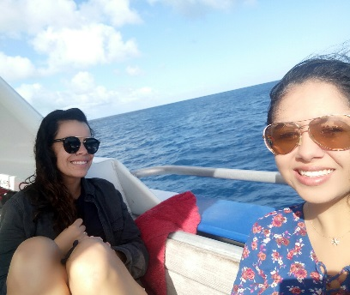
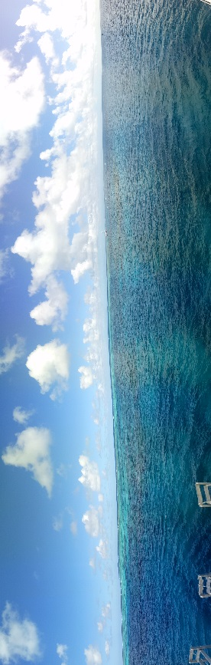
Really, I cannot wait to go back to the Great Barrier Reef and this time I’m planning to go SCUBA diving – and see for myself what sights and creatures are to be found in the depths.

Daniela Lopez

